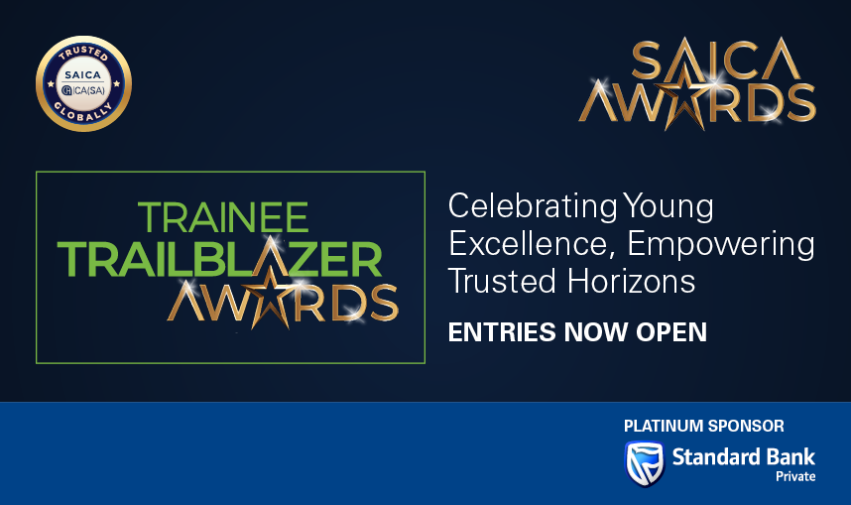

Trainee Trailblazers Awards: Entry/Project Motivation

Profile

- Name and Surname:
- Contact number:
- Email Address:
- Which category/categories are you entering for the Trainee Trailblazer Awards?
- Reasons for entry (Why are you entering the Awards (add motivation)
Categories specific questions: Please answer ONLY questions that are applicable to the category you have entered.

1. Disruptive Innovator Award:
- Describe the innovation or solution you initiated, highlighting how the challenge or problem you identified inspired its creation.
- What specific problem is the innovation addressing?
- How does your innovation challenge existing and traditional practices?
- What measurable impact has your innovation achieved?
- What was your personal role in developing and implementing the solution?
- How does this innovation ensure the future relevance and sustainability of our profession, while also driving positive change and delivering lasting impact for society and the communities we serve?
- What does the future look like for your product/service/initiative, and how will it continue to create impact?
2. Social and Sustainability Award:
- Describe the initiative or project, explaining the challenge or need that inspired it, and highlight how your solution aligns with and advances one or more UN Sustainable Development Goals (SDGs)
- Which SDG(s) does your work primarily address, and why are these goals most relevant to your initiative?
- Who are your primary beneficiaries, and how are their needs being met through your project?
- Explain your personal leadership role in driving this initiative or venture?
- What measurable impact have you achieved so far (quantitative or qualitative)?
- How do you ensure sustainability and long-term relevance of this initiative?
- What does the future look like for your product/service/initiative, and how will it continue to scale or create impact in advancing the SDGs?
3. Wellness Advocate Award:
- Describe the personal and professional challenges you faced during your trainee journey. Explain how these challenges inspired you to develop a solution, leading to the initiative, project, or programme you created or LEDB. How did you demonstrate resilience and determination in overcoming these challenges?
- What achievements did you accomplish despite the challenges?
- How are you advocating for wellness within your trainee community/other spaces?
- What measurable impact has your wellness advocacy had on others?
- What lessons from your experience could benefit others in their personal or professional journeys?
- What does the future look like for your product/service/initiative, and how will it remain sustainable while continuing to deliver positive impact for communities and society?
4. SAICA brand ambassador:
- Why do you believe you should be selected for the SAICA Ambassador Award? Describe the motivation behind your advocacy, and demonstrate it with specific examples such as campaigns, speaking engagements, mentoring, social media, or initiatives. (Provide specific examples such as campaigns, speaking engagements, mentoring, social media, or initiatives.)
- What impact has your advocacy had on the profession, students, or the broader community?
(Describe outcomes, results, or changes influenced by your actions.)
- Who has benefited from your advocacy, and how?
- (e.g. students, young professionals, communities, organisations)
- What platforms or channels have you used and what audiences are you targeting?
- How do you demonstrate SAICA’s values (integrity, professionalism, ethical leadership) in your work and public presence? (Provide at least one real example.)
- Please attach evidence of your engagements, campaigns posts etc. including performance metrics as evidence relates to social media platforms.
- How have you contributed to building a more inclusive, diverse, and accessible profession?
(Provide examples of initiatives, mentorship, or advocacy work.)
Delete ALL nonrelevant Sections for your submissions

