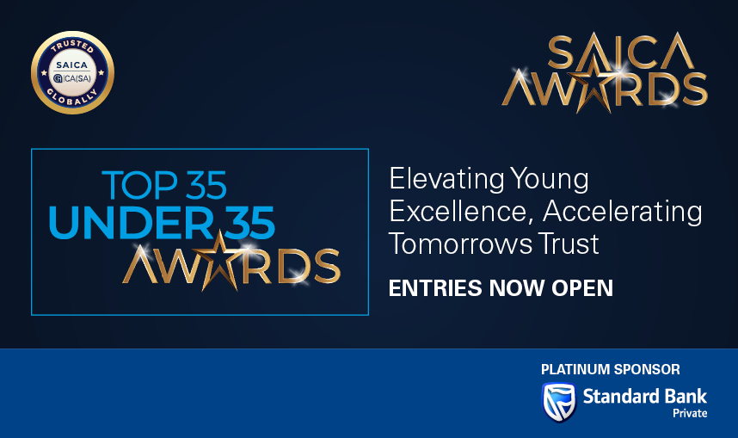

Top 35-Under-35 Awards: Entry/Project Motivation

Profile

- Name and Surname:
- Contact number:
- Email Address:
- Which category/categories are you entering for the Top 35-Under-35 Awards?
- Reasons for entry (Why are you entering the Awards (add motivation)

Categories specific questions: Please answer ONLY questions that are applicable to the category you have entered.

Transformative Leader Award – Entry Questions
- Describe a significant transformation or change you have led within your organisation or community, highlighting the challenge or need that inspired it, your vision, and what you aimed to achieve.
(What was your vision, and what did you aim to achieve?)
- How did you communicate and gain buy-in for this vision?
(Explain how you aligned others and drove the change forward.)
- What measurable outcomes demonstrate the success of this transformation?
(Provide clear results, improvements, or impact.)
- Provide specific examples of how you have mentored, coached, or supported the development of others.
- What impact has your leadership and mentorship had on individuals or teams?
(e.g. career progression, skills development, confidence, leadership growth)
- How have you influenced stakeholders or built consensus to achieve your goals?
(e.g. leadership teams, peers, external partners)
- Describe a situation where you successfully inspired or mobilised others toward a shared goal.
- Provide evidence or examples to support your responses (e.g. testimonials, results, links, case studies).
Impact Champion Award – Entry Questions
- Describe the initiative you initiated and spearheaded, the outcomes you set out to achieve, and how it delivered meaningful social or economic change.
- What measurable impact has been achieved?
(Include data such as number of beneficiaries, financial impact, outcomes, or improvements.)
- Who has benefited from your work, and how?
- What makes your approach innovative compared to existing solutions?
- How is your initiative scalable or replicable for greater impact?
(Explain potential for growth or expansion.)
- What role did you play in leading and executing this initiative from concept to delivery?
- What challenges did you face, and how did you overcome them to ensure success?
- Provide evidence of your impact (data, reports, links, testimonials, case studies).
Future-Fit Innovator Award – Entry Questions
- Describe the innovative solution, technology, or process you initiated and led, and how it represents forward-thinking innovation.
- What makes this innovation original, creative, or forward-thinking?
- How was this innovation implemented within your organisation or the profession or the broader society?
- What challenges did you encounter during implementation, and how did you overcome them to ensure success?
- To what extent has the innovation been successfully adopted?
(e.g. usage, integration, behavioural change)
- How has this innovation improved efficiency, accuracy, or future-readiness within the accounting profession and broader industries or society.
- What broader impact has this innovation created for the profession or beyond your organisation?
- Provide examples or evidence of the innovation in practice (links, tools, outputs, results).
Wellness Advocate:
- Describe the personal and professional challenges you faced during your personal and professional journey. Explain how these challenges inspired you to develop a solution, leading to the initiative, project, or programme you created or led.
- How did you demonstrate resilience and determination in overcoming these challenges?
- What achievements did you accomplish despite the challenges?
- How are you advocating for wellness within your trainee community/other spaces?
- What measurable impact has your wellness advocacy had on others?
- What lessons from your experience could benefit others in their personal or professional journeys?
- What does the future look like for your product/service/initiative and how will it remain sustainable while continuing to deliver positive impact for communities and society?
SDG Champion Award:
- Describe the initiative or project, explaining the challenge or need that inspired it, and highlight how your solution aligns with and advances one or more UN Sustainable Development Goals (SDGs)
- Which SDG(s) does your work primarily address and why are these goals most relevant to your initiative?
- Who are your primary beneficiaries and how are their needs being met through your project?
- Explain your personal leadership role in driving this initiative or venture?
- What measurable impact have you achieved so far (quantitative or qualitative)??
- How do you ensure sustainability and long-term relevance of this initiative? What does the future look like for your product/service/initiative, and how will it continue to scale or create impact in advancing the SDGs?
SAICA brand ambassador Award:
- Why do you believe you should be selected for the SAICA Ambassador Award? Describe the motivation behind your advocacy, and demonstrate it with specific examples such as campaigns, speaking engagements, mentoring, social media, or initiatives. (Provide specific examples such as campaigns, speaking engagements, mentoring, social media, or initiatives.)
- What impact has your advocacy has had on the profession, students, or the broader community? (Describe outcomes, results, or changes influenced by your actions.)
- Who has benefited from your advocacy, and how? (e.g. students, young professionals, communities, organisations)
- What platforms or channels have you used and what audience are you targeting?
- How do you demonstrate SAICA’s values (integrity, professionalism, ethical leadership) in your work and public presence? (Provide at least one real example.)
- Please attach evidence of your engagements, campaigns posts etc. including performance metrics as evidence relates to social media platforms.
- How have you contributed to building a more inclusive, diverse, and accessible profession? (Provide examples of initiatives, mentorship, or advocacy work.)
Delete ALL nonrelevant Sections for your submissions

