Example Reflection Journal for “Professional Values an Attitudes”

Acumens | Competency / learning outcomes identified on reflective plan for development |  | Required level | Proficiency level before training | Intervention addressed | Proficiency level after training | Further learning interventions required
Ethics, Values and Attitudes | Personal Ethics | Act honestly and demonstrate personal integrity, accountability and trustworthiness whilst interacting with others. | 4 |  |  |  | Yes/No
 |  | Carry out work in a manner that protects public interest, the client, employer, and other relevant stakeholders, and put these before one’s own interest. | 4 |  |  |  | Yes/No
 |  | Evaluate the impact of different value systems implicit in, among others, religion, culture, social standing, economic status, and personal experiences. | 4 |  |  |  | Yes/No
 |  | Understand ethics theories (normative and applied) and apply relevant theories when solving personal ethical dilemmas or making personal ethical decisions. | 4 |  |  |  | Yes/No

Acumens | Competency / learning outcomes identified on reflective plan for development |  | Required level | Proficiency level before training | Intervention addressed | Proficiency level after training | Further learning interventions required
 | Business Ethics | Evaluate the significance of ethics within the business environment, and the ways in which it is managed within an organisation, as part of its ethical organizational culture. | 4 |  |  |  | Yes/No
 |  | Analyse the interrelationships between governance, ethics, work values and the law. | 4 |  |  |  | Yes/No
 |  | Display ethical behaviour whilst interacting with the organisation’s stakeholders. | 4 |  |  |  | Yes/No
 |  | Report ethics related issues to higher level of management, legal or regulatory authorities or others, when appropriate. | 4 |  |  |  | Yes/No
 |  | Understand ethics theories (normative and applied) and apply relevant theories when solving business ethical dilemmas or making business ethical decisions. | 4 |  |  |  | Yes/No
 | Professional ethics | Relate professional ethics to the notion of public interest by being competent and delivering quality work. | 4 |  |  |  | Yes/No
 |  | Distinguish between ethical principles and rules of conduct, and apply the fundamental ethical principles of integrity, objectivity, professional competence and due are, confidentiality and professional behaviour when rendering services. | 4 |  |  |  | Yes/No
 |  | Identify threats to ethical principles and apply appropriate safeguards to facilitate ethical behaviour. | 4 |  |  |  | Yes/No
 |  | Use an ethical reasoning process (based on ethics theories and professional values and attitudes and the code of professional conduct) to solve professional ethics dilemmas. | 4 |  |  |  | Yes/No
 |  | Analyse all courses of potentially unethical action as well as the consequences of each (e.g., disciplinary actions) | 4 |  |  |  | Yes/No
 |  | Report ethical issues to SAICA, legal or regulatory authorities or others when appropriate. | 4 |  |  |  | Yes/No
 |  | By way of general conduct, demonstrate a commitment to the ethical values upheld by the profession. | 4 |  |  |  | Yes/No

Intervention | Date
Example: SAICA Ethics Technical Training

Reflection model used:
- What?
- So What?
- Now What?

What?
Key learnings
- ______________________________________________________________________________________________________________________________
- ______________________________________________________________________________________________________________________________
- ______________________________________________________________________________________________________________________________
- ______________________________________________________________________________________________________________________________
- ______________________________________________________________________________________________________________________________
- ______________________________________________________________________________________________________________________________
- ______________________________________________________________________________________________________________________________
- ______________________________________________________________________________________________________________________________
- ______________________________________________________________________________________________________________________________
- ______________________________________________________________________________________________________________________________

So What? (Relevance and Fit)
What is the relevance to my daily role? | What is the relevance to my organisation? | What is the relevance to my clients? | Wat is the relevance to my organisation’s stakeholders / broader society?
Now What? (Applying what you have learned)
Personal change
What should I START doing?
Example
- Consider developing your own values based code of conduct. Start by reviewing the values discussed in the webinar and identify your top 10 values
- This is the same exercise that was included as part of the values study at universities as part of a longitudinal study 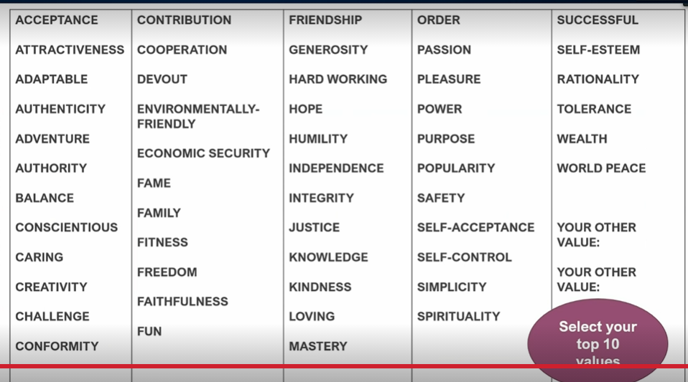_
- Consider this second slide by Prof Ilse – reflect on the relationship between your personal values and the organisational values 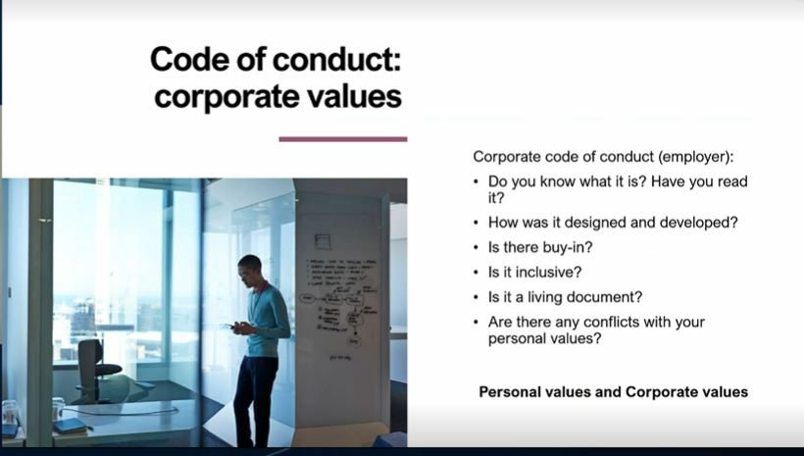___________________________________________________________________________________________________________________________
________________________________________________________________________________________________________________________________
________________________________________________________________________________________________________________________________
________________________________________________________________________________________________________________________________

What should I STOP doing?
Example: A possible question posed by Prof Benda which you can consider reflecting on here is:
- Do you consider such a rigid moral mindset as the hallmark of an incorruptible moral character?
- Do you experience the moral contestation of your values as threatening, and if so, why?
What is strong is constantly tested in battle – exposed to contestation – rather than something I hold onto & guard from exposure to alternative value estimations = fundamentalism
______________________________________________________________________________________________________________________________
________________________________________________________________________________________________________________________________
________________________________________________________________________________________________________________________________
________________________________________________________________________________________________________________________________

What should I CONTINUE doing?
________________________________________________________________________________________________________________________________
________________________________________________________________________________________________________________________________
________________________________________________________________________________________________________________________________
________________________________________________________________________________________________________________________________

Organisational change
What changes in the organisational policies/ procedures are needed for these strategies/ key learnings to be implemented?
________________________________________________________________________________________________________________________________
________________________________________________________________________________________________________________________________
________________________________________________________________________________________________________________________________
________________________________________________________________________________________________________________________________
________________________________________________________________________________________________________________________________

Effectiveness of learning intervention
________________________________________________________________________________________________________________________________
________________________________________________________________________________________________________________________________
________________________________________________________________________________________________________________________________
________________________________________________________________________________________________________________________________

Other areas identified for development / Additional learning interventions required
________________________________________________________________________________________________________________________________
________________________________________________________________________________________________________________________________
________________________________________________________________________________________________________________________________

Professional values and attitudes are defined as the professional behaviour and characteristics that identify chartered accountants (CAs) as members of the CA profession (IFAC, 2017)
As per Circular 2/2021, all members are required to function at proficiency level 4 https://www.saica.co.za/Portals/0/documents/2021/Circular_final_CPD%20policy_April_2021_41_.pdf
Refer the proficiency level table (https://ca2025.co.za/wp-content/uploads/2020/04/proficiencylevelsoriginal-1.pdf) for detailed explanation of various levels
This competency area includes personal, business, and professional ethics and describes the ethical principles, values, and attitudes an individual must apply, also when interacting with others.
Refer to a personal value system applied by an individual to decision-making, conduct and interaction between the self and others.
As per Circular 2/2021, all members are required to function at proficiency level 4 https://www.saica.co.za/Portals/0/documents/2021/Circular_final_CPD%20policy_April_2021_41_.pdf
Refer the proficiency level table (https://ca2025.co.za/wp-content/uploads/2020/04/proficiencylevelsoriginal-1.pdf) for detailed explanation of various levels
Refer to the ethical principles and values applied by the organisation to decision-making, conduct and the relationship between the organisation, its stakeholders and society (KING IV).
Refer to the fundamental ethical principles and values applied by a professional CA to decision-making, conduct and the relationship between the professional, its stakeholders and society.

