Disciplinary Report for Q4 of 2020

1. Overview of the Disciplinary Process under the Revised By-laws (as at 1 June 2020)

All member complaints received by SAICA are referred to the Designated Officer and allocated to the Legal and Discipline Unit staff for case management. All cases in which SAICA has jurisdiction are prepared for submission to either the Professional Conduct Committee (PCC) or the Disciplinary Committee (DC).

The PCC is an independent committee, chaired by either an advocate or an attorney and also consisting of members of SAICA who volunteer their services to form part of the Disciplinary Panel. The PCC consider matters which fall within the Schedules to the Disciplinary Code (1A; 1B; 2A, 2B, 3A and 3B).
The PCC also considers the ethical component of Fit and Proper Inquiries in order to decide whether persons meeting the academic and experience requirements are fit and proper for acceptance into membership and whether former or prospective Trainee Accountants should be allowed to register/re-register training contracts with SAICA.

The SAICA Legal and Disciplinary staff prepare the complaint documentation for submission to the PCC for consideration and finalisation. The PCC has the authority to call on the accused person to appear before the committee to give any additional evidence. No legal representation is allowed at the PCC meeting. The decision of the PCC is final.

Where a matter is referred to the Disciplinary Committee (DC) for a formal hearing, the accused person is allowed legal representation and may lead witnesses and introduce documentary evidence. The Parties may enter into without prejudice settlement discussion at any time prior to the commencement of the Disciplinary Committee hearing and may submit a settlement order to the DC for approval. The DC may choose to, depending on the nature of the matter before it, proceed either by way of an oral hearing or alternatively on the basis of affidavits and/or witness statements and/or documents.

In the event that the accused person is found guilty of improper conduct, the Disciplinary Committee may impose the following sanctions: a caution; a reprimand; a fine not exceeding R500 000 (five hundred thousand rand) per charge; suspension; exclusion or disqualification from membership; associateship or traineeship of SAICA. The DC hearings are open to the public and dates of DC hearings are communicated on the SAICA Governance website.

2. Report on Case Management

2.1 Professional Conduct Committee (PCC)

The PCC met 7 (seven) times during Q4 and considered 57 (fifty-seven) cases.
56 (fifty-six) cases were finalised with 1 case requiring further investigation.

Complaints Trends

Trends (Q4. Oct- Dec 2020)
Fit and Proper (Trainee) | 17
Fit and Proper (CA/AGA) | 1
Integrity | 2
Competence | 2
Objectivity | 1
Prof. Behaviour | 2
Confidentiality | 0
Tax Practitioner Non-Compliance | 16
Training Officer Misconduct | 0
Exam Regulations | 0
Trainee Misconduct | 16
Failure to Respond | 0
Total | 57

Sanctions from the Professional Conduct Committee

Professional Conduct Committee- Sanctions Imposed
(Q4. Oct - Dec 2020)
Fit and Proper for Traineeship | 13
NOT Fit and Proper for Traineeship | 4
Fit and Proper for Membership/Associateship | 1
NOT Fit and Proper for Membership/Associateship | 0
Fines imposed | 16
No Improper conduct found | 9
On-going/part heard | 1
PCC ordered investigation in absence of formal complaint | 0
Penalty period imposed on Training Contract | 13
Total | 57

2.2 Disciplinary Committee (DC)

The DC met twice during Q4.
The Disciplinary Committee handed down the following Rulings:
- A Fine in the amount of R150 000 (one hundred and fifty thousand rand) together with a suspension from Associateship of SAICA, which suspension was wholly suspended for a period of 3 years on conditions;
- A Fine in the amount of R100 000 (one hundred thousand rand) of which amount R75 000 (seventy-five thousand rand) was suspended on conditions
- A suspension from membership for a period of 5 years of which suspension 2 years were suspended on conditions.

One matter is part-heard before the Disciplinary Committee.

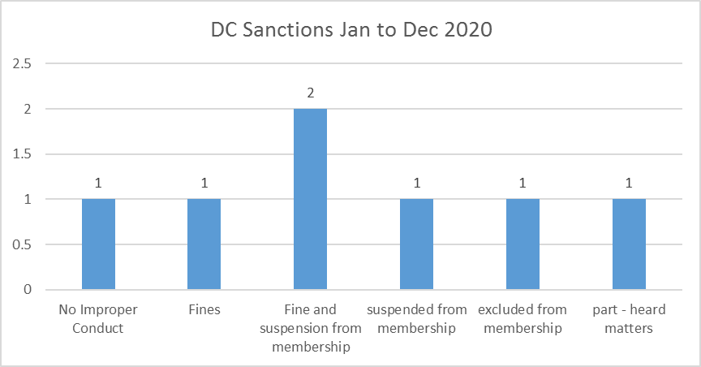

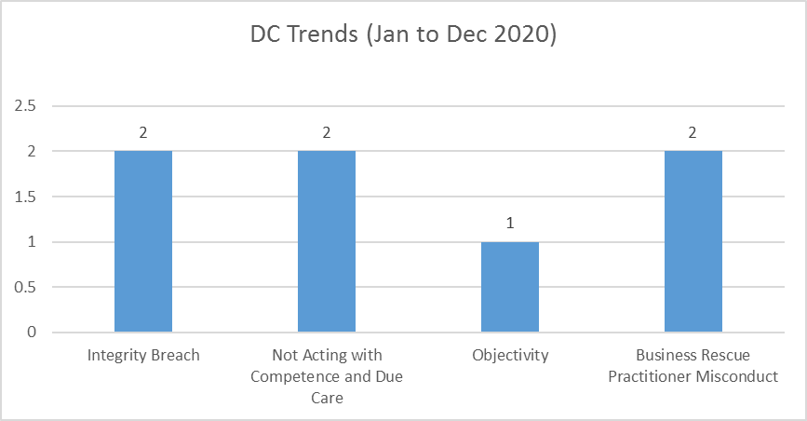

3. Publishing of Rulings in Finalised Cases where Respondents have been found guilty of improper conduct– Q4 of 2020

Matter One:
Mr. Anele Mzini was found guilty of improper conduct for failing to comply with the company’s policies and procedures and act in good faith. This amounted to a breach of By-laws 34.12 and 34.13 read with sections 100, 115.1 and 115.1 A1 of the Code of Professional Conduct by failing to comply with the fundamental principle of Professional Behaviour. The Professional Conduct Committee imposed a sanction of 3 (three) months extension to his training contract.
The Professional Conduct Committee found Mr. Mzini Fit and Proper to register a new training contract.

Matter Two:
Mr. Paul de Jager was found guilty of improper conduct for failing to return to his training office after he applied and was granted a 12 (twelve) month academic suspension. This amounted to a breach of By-laws 34.12 and 34.13 read with sections 100, 115.1 and 115.1 A1 of the Code of Professional Conduct by failing to comply with the fundamental principle of Professional Behaviour. The Professional Conduct Committee imposed a sanction of 6 (six) months extension to his training contract.
The Professional Conduct Committee found Mr. de Jager Fit and Proper to register a new training contract.

Matter Three:
Ms. Bomkazi Hlwatika was found guilty of improper conduct for resigning from her trainee position and failing to serve a 4 (four) week notice. This amounted to a breach of By-laws 34.12 and 34.13 read with sections 100, 115.1 and 115.1 A1 of the Code of Professional Conduct by failing to comply with the fundamental principle of Professional Behaviour. The Professional Conduct Committee imposed a sanction of 6 (six) months extension to her training contract.
The Professional Conduct Committee found Ms. Hlwatika Fit and Proper to register a new training contract.

Matter Four:
Mr. Nhlanhla Sifiso Madonsela was found guilty of improper conduct for breaching his contract of employment by failing to serve a 30 (thirty) day notice period. This amounted to a breach of By-laws 34.12 and 34.13 read with sections 100, 115.1 and 115.1 A1 of the Code of Professional Conduct by failing to comply with the fundamental principle of Professional Behaviour. The Professional Conduct Committee imposed a sanction of 6 (six) months extension to his training contract. The Professional Conduct Committee found Mr. Madonsela Fit and Proper to register a new training contract.

Matter Five:
Mr. Samkele Thabethe was found guilty of improper conduct for having resigned with immediate effect and failing to give 2 (two) weeks’ notice. This amounted to a breach of By-laws 34.12 and 34.13 read with sections 110.1 A (a) and (e), 115.1 and 115.1 A1 of the Code of Professional Conduct by failing to comply with the fundamental principle of Professional Behaviour. The Professional Conduct Committee imposed a sanction of 6 (six) months extension to his training contract.
The Professional Conduct Committee found Mr. Thabethe not Fit and Proper to register a new training contract.
The Professional Conduct Committee found Mr. Thabethe ineligible to reapply for Fit and Proper for a period of 3 (three) months.

Matter Six:
Mr. Tebogo Mahapa was found guilty of improper conduct for committing acts of sexual harassment against 2 (two) female employees. This amounted to a breach of By-laws 34.12 and 34.13 read with sections 110.1 A (a) and (e), 115.1 and 115.1 A1 of the Code of Professional Conduct by failing to comply with the fundamental principle of Professional Behaviour. The Professional Conduct Committee imposed a sanction of 12 (twelve) months extension to his training contract.
The Professional Conduct Committee found Mr. Mahapa not Fit and Proper to register a new training contract.
The Professional Conduct Committee found Mr. Mahapa ineligible to reapply for Fit and Proper for a period of 6 (six) months.
The Professional Conduct Committee found that Mr. Mahapa should attend the SAICA Ethics Course as well as a Sexual Harassment Course and to produce certificates of attendance upon completion.

Matter Seven:
Removed (matter publication period expired).

Matter Eight:
Mr. Gabula Mqoboli was found not Fit and Proper to register a new training contract. The Professional Conduct Committee found Mr. Mqoboli ineligible to reapply for Fit and Proper for a period of 12 (twelve) months.
The Professional Conduct Committee elected to not rule on the misconduct.

Matter Nine:
Ms. Nonhlanhla Buthelezi was found guilty of improper conduct for failing to comply with the minimum 15 (fifteen) hours of tax specific CPD which had to be verifiable for the 2016 period. This amounted to breach of By-laws 34.13 of the SAICA By-Laws read with Sections 100.5(c), 130.1 and 130.3 of the Code of Professional Conduct.
The Professional Conduct Committee imposed a fine of R100 000 (one hundred thousand rand), wholly suspended for a period of 3 (three) years and a reprimand for her conduct.

Matter Ten:
Removed (matter publication period expired).

Matter Eleven:
Removed (matter publication period expired).

Matter Twelve:
Ms. Larissa Bhagwandin was found guilty of improper conduct for false allocations of travel expenses. The Professional Conduct Committee imposed a sanction of 6 (six) months extension to her training contract and Ms. Bhagwandin is required to provide proof of having completed a SAICA Ethics Course.
The Professional Conduct Committee found Ms. Bhagwandin Fit and Proper to register a new training contract.

Matter Thirteen:
Mr. Avick Misra was found guilty of improper conduct for failing to disclose a financial interest and financial benefits received by a company that fell into the portfolio of his audit. This amounted to a breach of sections 100 and 112 of the Code of Professional Conduct by failing to comply with the fundamental principle of Objectivity.
The Professional Conduct Committee imposed a fine of R20 000 (twenty thousand rand), with R10 000 partially suspended for a period of 3 (three) years and a reprimand and caution for his conduct in respect of objectivity. Furthermore, Mr. Misra is required to provide proof of having completed the SAICA’s Ethics Course within 1 (one) year of the finding.

Matter Fourteen:
Removed (matter publication period expired).

Matter Fifteen:
Ms. Nthabeleng Sebatlelo was found guilty of improper conduct for Failure to complete and submit 3 (three) successive Assessment Needs Analysis (“ANA”), for periods B1, B2 and C1, or other documentation on timeously. The Professional Conduct Committee imposed a sanction of 6 (six) months extension to her training contract and Ms. Sebatlelo is required to provide proof of having completed the SAICA’s Ethics Course.
The Professional Conduct Committee found Ms. Sebatlelo Fit and Proper to register a new training contract.

Matter Sixteen:
Mr. Sean Colin Strever was found guilty of improper conduct for his failure to comply with the Continuing Professional Development (CPD) hours required of a Tax Practitioner for the 2017 period. This amounted to a breach of By-laws 13.13 of the SAICA By-Laws read with Sections 100.5(c), 130.1 and 130.3 of the Professional Code of Conduct.
The Professional Conduct Committee imposed a fine of R30 000 (thirty thousand rand), wholly suspended for a period of 3 (three) years and a reprimand for his conduct.

Matter Seventeen:
Mr. Mohammed Limbada was found guilty of improper conduct in relation to the allegation that he was dishonest and advised his former employer that that one of its clients was going to follow him when he left the firm. Mr. Limbada’s conduct amounted to a breach of By-Laws 53.1 and 53.3 of the 2018 By-Laws read with Sections 100; 110.1 and R115 of the SAICA Code of Professional Conduct and Annexure 3 of the Training Regulations at 2.6.
The Professional Conduct Committee imposed a sanction of 9 (nine) months extension to his training contract and Mr. Limbada is required to, inter alia, provide proof of having completed the SAICA’s Ethics Course.
The Professional Conduct Committee found Mr. Limbada Fit and Proper to register a new training contract.

Matter Eighteen:
Removed (matter publication period expired).

Matter Nineteen:
OUTCOME OF THE PROFESSIONAL CONDUCT COMMITTEE – 8 OCTOBER 2020: CHARL CILLIERS
The Professional Conduct Committee convened on 8 December 2020 to consider the contents of the VBS Mutual Bank, the Great Bank Heist, Investigator’s Report to the Prudential Authority and the annexures thereto (“the VBS Report”), for any alleged improper conduct by Mr. Charl Cilliers, who at the time of the VBS Report was the CEO of Insure Group (“Cilliers”).
Upon consideration of the facts, evidence and independent documentation and reports, the Professional Conduct Committee found that there was no evidence of any improper conduct committed by Cilliers. The matter of any alleged misconduct by Cilliers, in respect of the VBS Report, was subsequently dismissed.

Note on Publication of DC Ruling:
Publication will be made once Court proceedings have been finalised.

SAICA Legal and Discipline

