Disciplinary Report for Q3 of 2021:

- Overview of the Disciplinary Process under the Revised By-laws (as at 1 June 2020)

All member complaints received by SAICA are referred to the Designated Officer and allocated to the Legal and Discipline Unit staff for case management. All cases in which SAICA has jurisdiction are prepared for submission to either the Professional Conduct Committee (PCC) or the Disciplinary Committee (DC).

The PCC is an independent committee, chaired by either an advocate or an attorney and also consisting of members of SAICA who volunteer their services to form part of the Disciplinary Panel. The PCC consider matters which fall within the Schedules to the Disciplinary Code (1A; 1B; 2A, 2B, 3A and 3B).

The PCC also considers the ethical component of Fit and Proper Inquiries in order to decide whether persons meeting the academic and experience requirements are fit and proper for acceptance into membership and whether former or prospective Trainee Accountants should be allowed to register/re-register training contracts with SAICA.

The SAICA Legal and Disciplinary staff prepare the complaint documentation for submission to the PCC for consideration and finalisation. The PCC has the authority to call on the accused person to appear before the committee to give any additional evidence. No legal representation is allowed at the PCC meeting. The decision of the PCC is final.

Where a matter is referred to the Disciplinary Committee (DC) for a formal hearing, the accused person is allowed legal representation and may lead witnesses and introduce documentary evidence. The Parties may enter into without prejudice settlement discussion at any time prior to the commencement of the Disciplinary Committee hearing and may submit a settlement order to the DC for approval. The DC may choose to, depending on the nature of the matter before it, proceed either by way of an oral hearing or alternatively on the basis of affidavits and/or witness statements and/or documents.

In the event that the accused person is found guilty of improper conduct, the Disciplinary Committee may impose the following sanctions: a caution; a reprimand; a fine not exceeding R500 000 (five hundred thousand rand) per charge; suspension; exclusion or disqualification from membership; associateship or traineeship of SAICA. The DC hearings are open to the public and dates of DC hearings are communicated on the SAICA Governance website.

- Amendment to SAICA By-laws: Retention of Non-Audit Related Complaints against SAICA Member/Registered Auditor

In September 2021, the SAICA Board approved an amendment to the SAICA By-laws at paragraph 8.1.3 of the Disciplinary Code ( Appendix 4) which allows SAICA to retain any complaints against a SAICA member who is also a Registered Auditor with the IRBA, where the nature of the complaint does not seem to be audit-related. In such instances, SAICA will follow our disciplinary processes in investigating the complaint. In the event that the nature of a complaint received against a SAICA member who is also a Registered Auditor with the IRBA, appears to be audit-related, the complaint will then be referred to the IRBA to engage the IRBA disciplinary processes.

- Report on Case Management

Professional Conduct Committee (PCC)
The Professional Conduct Committee (PCC) met 10 times in Quarter 3 and considered 81 cases of which 79 cases where finalised (compared to 59 finalised and 2 cases are part-heard.

Of the 81 cases considered, 26 Respondents elected to settle their complaints by way of the new admission of guilt option in Q3 of 2021.

In addition to the meetings of the full PCC, the Advisory Committee met on 1 occasion and closed 5 complaints, where it was decided that these matters lacked prima facie evidence.

Accordingly, 84 complaints were finalised in Q3 and a total of 175 complaints have been finalised from Q1 to Q3 of 2021.

Trends (July – September 2021)
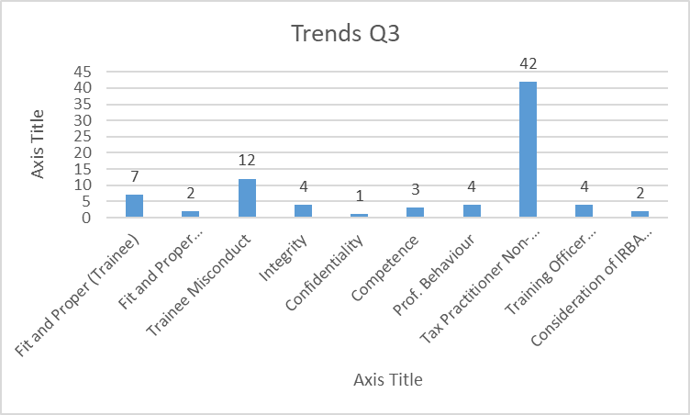

PCC sanctions (July- September 2021)
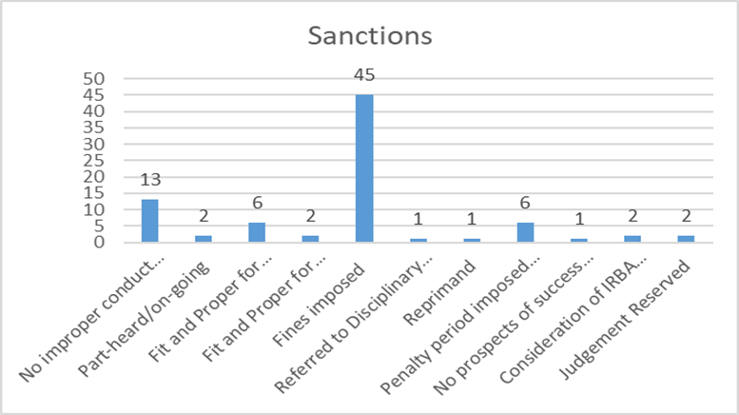
PROFESSIONAL CONDUCT COMMITTEE RULINGS IN TERMS OF SAICA BY-LAWS – JULY TO SEPTEMBER 2021 (AND ADDITIONAL MATTERS)
Matter One:
Denise Mattioda was found guilty of improper conduct for failure to comply with Tax Practitioner CPD. This amounted to a breach of 2016 By-laws, paragraph 34.13 read with sections 130.1 and 130.2 of the Code of Professional Conduct by failing to comply with the fundamental principle of Competence and Due Care.
The Professional Conduct Committee imposed a fine of R100 000 (one hundred thousand rand), wholly suspended for a period of 3 (three) years and a reprimand for her conduct.

Matter Two:
Craig Hanafey elected to pay to pay an admission of guilt fine in terms of Paragraph 9.1.7 of Appendix 4: Disciplinary Code and Procedures 2020 By-laws read with point 2 of schedule 1B, for failure to comply with Tax Practitioner CPD.
The Professional Conduct Committee imposed a fine of R100 000 (one hundred thousand rand), wholly suspended for a period of 3 (three) years and a reprimand for his conduct.

Matter Three:
Removed (matter publication period expired).

Matter Four:
Removed (matter publication period expired).

Matter Five:
Removed (matter publication period expired).

Matter Six:
Removed (matter publication period expired).

Matter Seven:
Removed (matter publication period expired).

Matter Eight:
Removed (matter publication period expired).

Matter Nine:
Removed (matter publication period expired).

Matter Ten:
Thandolwakhe Mhlongo was found guilty of improper conduct in terms of paragraphs 4.1.7 and 4.2.5 of the 2020 By-laws and Paragraph 2 of Annexure 3 of the SAICA Training Regulations: in that he failed to comply with any regulation, By-law or Code of Professional Conduct; committed a breach of any rule or any provision of the Code of Professional Conduct; and, failed to comply with the training office policies and procedures. The relevant provision of the Code of Professional Conduct which the Respondent’s conduct appears prima facie to be in contravention of is a breach of section 110.1 A1 read with subsection 115.1: Professional Behaviour.
The Professional Conduct Committee imposed a reprimand; a sanction of 6 (six) months extension to his training contract; and a Fit and Proper Enquiry is to be convened.

Matter Eleven:
Lorenzo Powell was found guilty of improper conduct in terms of Paragraphs 4.1.7 and 4.2.5 of the 2020 By-laws and Paragraph 20.5 of the SAICA Training Regulations: in that he failed to comply with any regulation, By-law or Code of Professional Conduct; committed a breach of any rule or any provision of the Code of Professional Conduct; and failed return to the training office when the period of suspension expired. The relevant provision of the Code of Professional Conduct is section 110.1 A1 read with subsection 115.1: Professional Behaviour.
The Professional Conduct Committee imposed a sanction of 6 (six) months extension to his training contract; and a Fit and Proper Enquiry is to be convened.

Matter Twelve:
Mmatlou Rammutla was found guilty of improper conduct in terms of Paragraphs 4.1.7 and 4.2.5 of the 2020 By-laws and Paragraph 2 of Annexure 3 of the SAICA Training Regulations: in that he failed to comply with any regulation, By-law or Code of Professional Conduct; committed a breach of any rule or any provision of the Code of Professional Conduct; and, failed to comply with the training office policies and procedures. The relevant provision of the Code of Professional Conduct is section 110.1 A1 read with subsection 115.1: Professional Behaviour.
The Professional Conduct Committee imposed a sanction of 6 (six) months extension to his training contract; and a Fit and Proper Enquiry is to be convened.

Matter Thirteen:
Mihlali Banti was found guilty of improper conduct in terms of paragraph 35.1.13 of the 2019 By-laws, Section 110.1 A1 read with subsection 115.1 of the Code of Professional Conduct.
The Professional Conduct Committee imposed a sanction of 6 (six) months extension to her training contract; and a Fit and Proper Enquiry is to be convened.

Matter Fourteen:
Removed (matter publication period expired).

Matter Fifteen:
Removed (matter publication period expired).

Matter Sixteen:
Removed (matter publication period expired).

Matter Seventeen:
Removed (matter publication period expired).

Matter Eighteen:
Deidre van Dyk was found guilty of improper conduct for failure to timeously submit assessments as per Training Regulations. This amounted to a breach of the 2020 By-laws, paragraph 4.1.7, read with subsections 113 and 115.1 of the Code of Professional Conduct and read with paragraphs 2.6 and 2.8 of Annexure 3 of the SAICA Training Regulations.
The Professional Conduct Committee imposed a reprimand for her conduct; a sanction of 6 (six) months extension to her training contract; and a Fit and Proper Enquiry is not necessary.

Matter Nineteen:
Johan Christo Fick was found guilty of improper conduct for failure to comply with Tax Practitioner CPD. This amounted to a breach of 2016 By-laws, paragraph 34.13 read with sections 130.1 and 130.2 of the Code of Professional Conduct by failing to comply with the fundamental principle of Competence and Due Care.
The Professional Conduct Committee imposed a fine of R50 000 (fifty thousand rand), wholly suspended for a period of 3 (three) years, and a reprimand for his conduct.

Matter Twenty:
Ramonato Moledi pleaded guilty and elected to pay an admission of guilt Fine. This was accepted in terms of Paragraph 9.1.7 of Appendix 4 of the Disciplinary Code and Procedures of 2020 By-laws.
The Professional Conduct Committee imposed a reprimand for his conduct; a sanction of 12 (twelve) month extension to his training contract; a Fine of R50 000 (fifty thousand rand) wholly suspended for a period of 3 (three) years; completion of an ethics course; and a Fit and Proper Enquiry is to be convened.

Matter Twenty-One:
Removed (matter publication period expired).

Matter Twenty-Two:
Removed (matter publication period expired).

Matter Twenty-Three:
Removed (matter publication period expired).

Matter Twenty- Four:
Removed (matter publication period expired).

Matter Twenty-Five:
Olwethu Maqubela was found guilty in terms of paragraphs 34.12 and 34.13 of the 2016 By-laws and Paragraph 2 of Annexure 3 of the 2017 SAICA Training Regulations: in that he failed to comply with any regulation, By-law or Code of Professional Conduct; committed a breach of any rule or any provision of the Code of Professional Conduct; and, failed to comply with the training office policies and procedures. The relevant provision of the Code of Professional Conduct is section 100 read with subsections 110: Integrity and 150: Professional Behaviour.
The Professional Conduct Committee imposed a reprimand; a 12 (twelve) month extension to be added to his training contract, of which 6 (six) months is suspended for the duration of his training contract, provided he does not commit or is found guilty of a similar offence; an ethic’s course; and a Fit and Proper Enquiry is to be convened.

Matter Twenty-Six:
Removed (matter publication period expired).

Matter Twenty-Seven:
Removed (matter publication period expired).

Matter Twenty-Eight:
Removed (matter publication period expired).

Matter Twenty-Nine:
Removed (matter publication period expired).

Matter Thirty:
Removed (matter publication period expired).

Matter Thirty-One:
Removed (matter publication period expired).

Matter Thirty-Two:
Removed (matter publication period expired).

Matter Thirty-Three:
Removed (matter publication period expired).

Matter Thirty-Four:
Removed (matter publication period expired).
Matter Thirty-Five:
Ayanda Khumalo was found guilty in terms of Paragraph 4.1 and 4.2: Appendix 4 of the Disciplinary Code of the 2020 By-laws, Section 110.1 A1 of the Code of Professional Conduct read with subsections 113: Professional Competence and Due Care and 115: Professional Behaviour.
The Professional Conduct Committee imposed a reprimand; a Fine of R20 000 (twenty thousand rand) wholly suspended for a period of 3 (three) years; and a Fine of R30 000 (thirty thousand rand) suspended for a period of 3 (three) years; and a Fit and Proper Enquiry is to be convened.

Matter Thirty-Six:
Removed (matter publication period expired).

Matter Thirty-Seven:
Removed (matter publication period expired).

Matter Thirty-Eight:
Removed (matter publication period expired).

Matter Thirty- Nine
Removed (matter publication period expired).

Matter Forty
Removed (matter publication period expired).

Matter Forty-One
Removed (matter publication period expired).

Matter Forty-Two
Removed (matter publication period expired).

Matter Forty-Three
Removed (matter publication period expired).

Matter Forty-Four
Removed (matter publication period expired).

Matter Forty-Five
Removed (matter publication period expired).

Matter Forty-Six
Removed (matter publication period expired).

Matter Forty-Seven
The Member’s name has been excluded due to on-going litigation. The member was found guilty of improper conduct for failure to comply with Tax Practitioner CPD. This amounted to a breach of By-laws 34.17 and 34.18 read with sections 100.5(c), 130.1 and 130.3 of the Code of Professional Conduct by failing to comply with the fundamental principle of Competence and Due Care.
The Professional Conduct Committee imposed a fine of R30 000 (thirty thousand rand) wholly suspended for a period of 3 (three) years, and a reprimand for his conduct.

Matter Forty- Eight
Charles Mogobene was found guilty of 2 charges of improper conduct of a Training Officer, in that he was not available when the training inspection was conducted; and failed to deregister Trainees on TCMS within 30 (thirty) days.
This amounted to a breach of -
paragraph 4.1.7 of the 2020 By-laws and paragraph 7.6 of the Training Regulations in respect of charge 1; and
paragraph 4.1.7 of the 2020 By-laws and paragraph 21.1.5 and/or 21.1.6; 21.18 and 21.19 of the Training Regulations in respect of charge 2.
The Professional Conduct Committee imposed -
a reprimand; a Fine of R50 000 (fifty thousand rand) of which R30 000 (thirty thousand rand) is suspended in respect of charge 1; and
a reprimand; a Fine of R50 000 (fifty thousand rand) of which R30 000 (thirty thousand rand) is suspended in respect of charge 2.

Matter Forty-Nine
Malesela Montja was found guilty of improper conduct for failure to comply with the required Tax Practitioner CPD hours. This amounted to a breach of By-laws 34.17 and 34.18 read with sections 100.5(c), 130.1 and 130.3 of the Code of Professional Conduct by failing to comply with the fundamental principle of Competence and Due Care.
The Professional Conduct Committee imposed a fine of R100 000 (one-hundred thousand rand) wholly suspended for a period of 3 (three) years, and a reprimand for his conduct.

Matter Fifty
Elia Christiaan Janse van Rensburg was found guilty of improper conduct in terms of -
Paragraph 4.2.3 of the 2020 By-laws in that he certified a document, without taking reasonable steps to ensure the correctness of such certificate or report, in respect of charge 1; and
paragraph 4.2.5 of the 202 By-laws in that he committed a breach of any rule or any provision of the Code of Professional Conduct prescribed by the Board from time to time in terms of By-law 20. The relevant provision of the Code of Professional Conduct is section 110.1 A1 read with subsection 113.1: Professional Competence and Due Care, in respect of charge 2.
The Professional Conduct Committee imposed a reprimand; a fine of R50,000 (fifty thousand rand) of which R45,000 (forty-five thousand rand) is suspended on condition that he not be found guilty of the same or a similar offence for a 3 (three) year period.
ADDITONAL PUBLICATIONS (FROM 2020 PCC Meetings):
Matter One:
Leon Appelcryn was found guilty of improper conduct for failure to comply with Tax Practitioner CPD. This amounted to a breach of By-laws 34.17 and 34.18 read with sections 100.5(c), 130.1 and 130.3 of the Code of Professional Conduct by failing to comply with the fundamental principle of Competence and Due Care.
The Professional Conduct Committee imposed a fine of R100 000 (one hundred thousand rand), which is wholly suspended for a period of 3 (three) years, and a reprimand for his conduct.

Matter Two:
John Kenneth Bircher was found guilty of improper conduct for failure to comply with Tax Practitioner CPD. This amounted to a breach of paragraph 34.13 of the 2011 By-laws read with sections 100.5(c), 130.1 and 130.3 of the Code of Professional Conduct by failing to comply with the fundamental principle of Competence and Due Care.
The Professional Conduct Committee imposed a fine of R100 000 (one hundred thousand rand), which is wholly suspended for a period of 3 (three) years, and a reprimand for his conduct.

Matter Three:
Removed (matter publication period expired).

The Designated Disciplinary Officer
SAICA Legal and Discipline

